**Experiment – 2.4**

**Student Name: Milan Sharma UID: 23MAI10003**

**Branch: ME – CSE - AIML Section/Group: MAI – 1 (A)**

**Semester: 1st Date of Performance: 11 Oct 2023**

**Subject Name: Python Programming Subject Code: 23 CSH 623**

1. **Aim of the Experiment :**

Write a python program to calculate sum of elements of array using function and find a factorial of a number using recursion.

1. **Objective of the Experiment :**

To calculate sum of elements of array using function and find a factorial of a number using recursion.

1. **Algorithm/ Steps for Experiment**

**Step 1:** Create a python file to perform the python programs.

**Step 2:** Create a function in python.

**Step 3:** Apply conditions in the function that you want to do

**Step 4:** Call the function.

**Step 5:** Print sum of all elements in the array.

**Step 6:** Print factorial of a number using function.

**Code for Experiment (Sum of array) :**

def array_sum(arr):

total = 0

for num in arr:

total += num

return total

# Example usage

array = [1, 2, 3, 4, 5]

print(array)

print("\nSum of array is :",array_sum(array))

**Result/Output :**

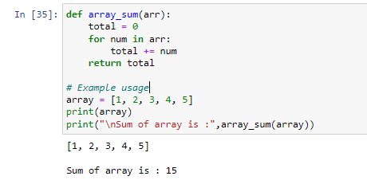

**Code for Experiment (Factorial of a number):**

def factorial(x):

if x == 1:

return 1

else:

return (x * factorial(x-1))

num = 7

result = factorial(num)

print("The factorial of", num, "is", result)

**Result/Output :**

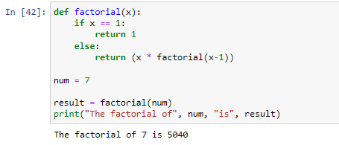

**Learning outcomes (What I have learnt):**

1. I learnt about the python language and its basic syntax.
2. I learnt about functions in python.
3. I learnt about how to find factorial.

**Evaluation Grid (To be created as per the SOP and Assessment guidelines by the faculty):**

|  |  |  |  |
| --- | --- | --- | --- |
| **Sr. No.** | **Parameters** | **Maximum Marks** | **Marks Obtained** |
| **1.** | **Student Performance**  **(Conduct of experiment)**  **Objectives/Outcomes.** | 12 |  |
| **2.** | **Viva Voce** | 10 |  |
| **3.** | **Submission of Work Sheet**  **(Record)** | 8 |  |